**Ideation Phase**

**Brainstorm & Idea Prioritization Template**

| Date | 19 September 2022 |
| --- | --- |
| Team ID | 609691 |
| Project Name | Deep Learning Model For Eye Disease Prediction |
| Maximum Marks | 4 Marks |

**Brainstorm & Idea Prioritization:**

Brainstorming provides a free and open environment that encourages everyone within a team to participate in the creative thinking process that leads to problem solving. Prioritizing volume over value, out-of-the-box ideas are welcome and built upon, and all participants are encouraged to collaborate, helping each other develop a rich amount of creative solutions.

**Step-1: Team Gathering, Collaboration and Select the Problem Statement**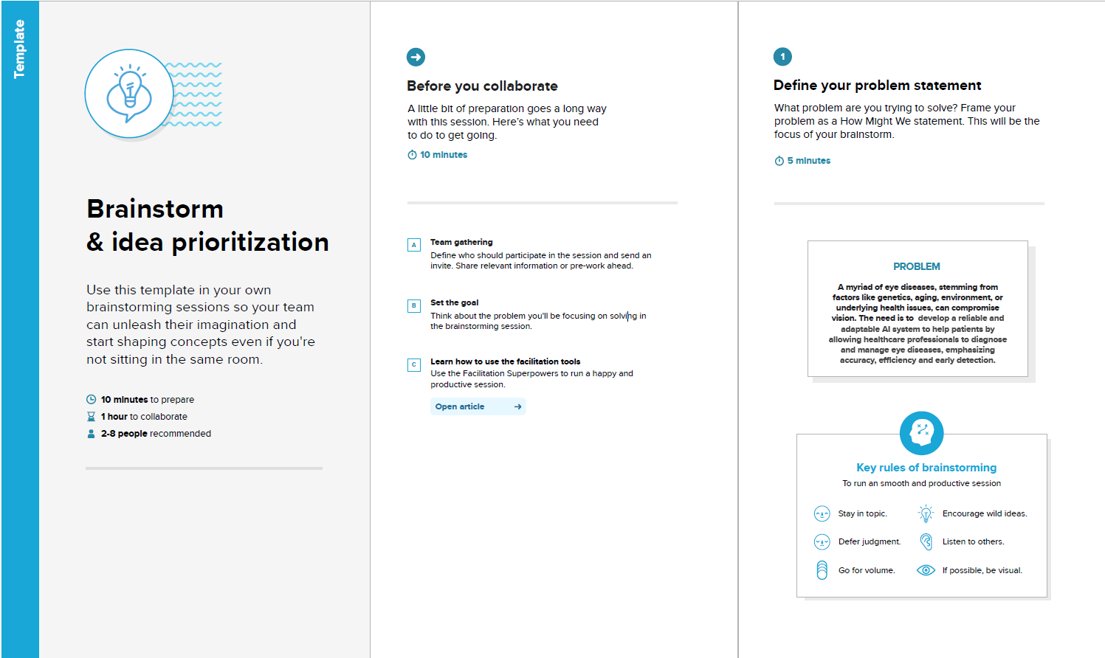

**Finalized Problem Statement:**

A myriad of eye diseases, stemming from factors like genetics, aging, environment, or underlying health issues, can compromise vision. The need is to develop a reliable and adaptable AI system to help patients by allowing healthcare professionals to diagnose and manage eye diseases, emphasizing accuracy, efficiency and early detection.

**Step-2: Brainstorm, Idea Listing and Grouping :**

All the team members came up with possible solutions based on their understanding and interpretation of the newly defined problem statement.

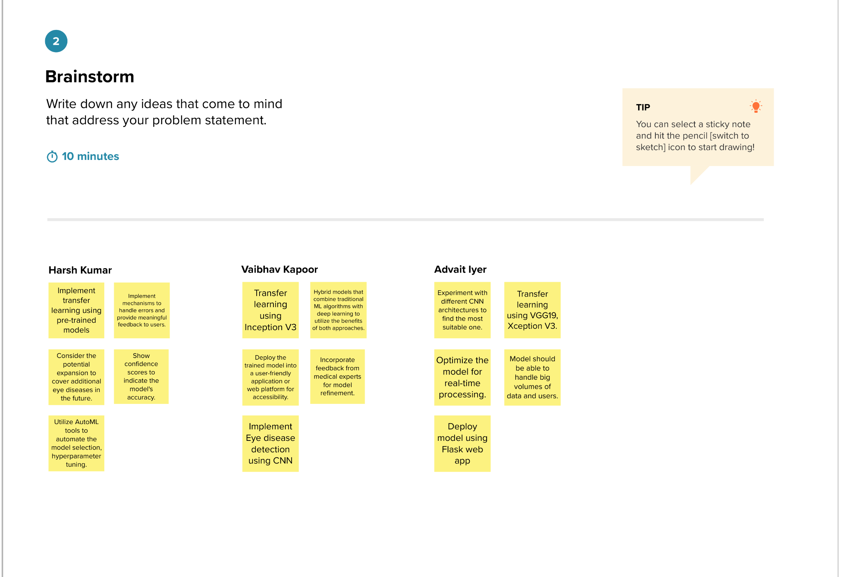

These 15 ideas are then clustered into following 6 clusters as shown in following figure:

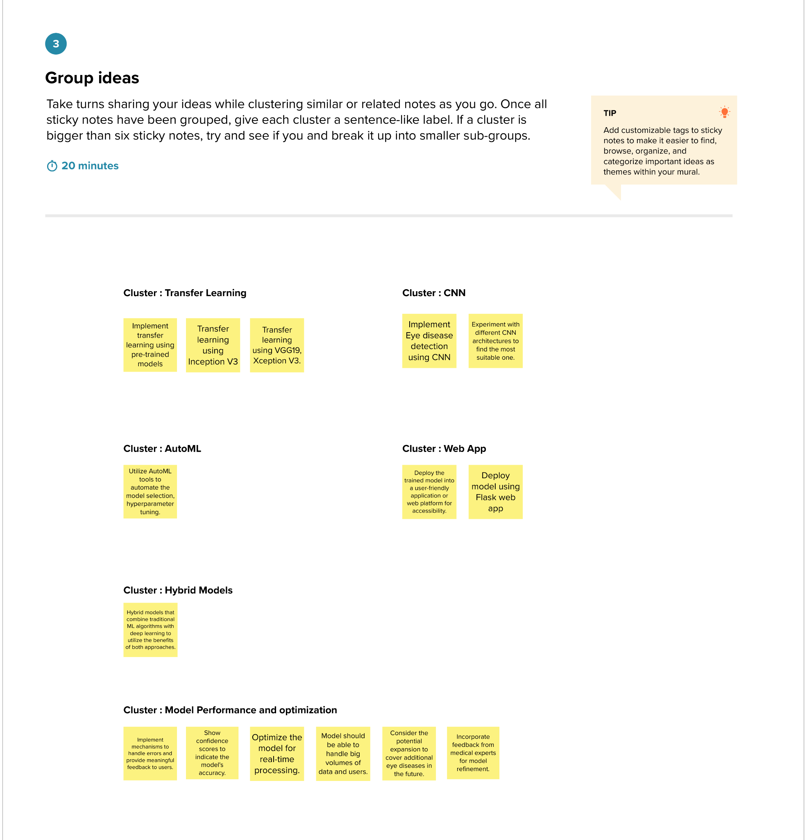

**RANKING THE IDEAS :**

The 13 ideas are ranked based on 4 factors : Impact, Feasibility, Cost and Alignment with goal.

**SCORES BY HARSH:**

| **CLUSTER** | **IDEA** | **SCORES BY HARSH** | | | | |
| --- | --- | --- | --- | --- | --- | --- |
| **Impact** | **Feasible** | **Cost** | **Alignment with goal** | **Total** |
| Transfer Learning | · Implement transfer learning using pre-trained models    · Transfer learning using Inception V3    · Transfer learning using VGG19, Xception V3. | 5 | 4.5 | 2 | 5 | 16.5 |
| CNN | · Implement Eye disease detection using CNN    · Experiment with different CNN architectures to find the most suitable one. | 4.5 | 4 | 3 | 5 | 16.5 |
| AutoML | Utilize AutoML tools to automate the model selection, hyperparameter tuning. | 3.5 | 3.5 | 2 | 5 | 14 |
| WebApp | · Deploy the trained model into a user-friendly application or web platform for accessibility.    · Deploy model using Flask web app | 4.5 | 4 | 2.5 | 4 | 15 |
| Hybrid Models | Hybrid models that combine traditional ML algorithms with deep learning to utilize the benefits of both approaches. | 3 | 2.5 | 3 | 5 | 13.5 |
| Model Performance and Optimization | Implement mechanisms to handle errors and provide meaningful feedback to users. | 3 | 2 | 4 | 3 | 12 |
| Model Performance and Optimization | Show confidence scores to indicate the model's accuracy. | 3 | 5 | 1 | 3.5 | 12.5 |
| Model Performance and Optimization | Optimize the model for real-time processing. | 2 | 2 | 3.5 | 3 | 10.5 |
| Model Performance and Optimization | Model should be able to handle big volumes of data and users. | 3.5 | 3 | 3.5 | 4.5 | 14.5 |
| Model Performance and Optimization | Consider the potential expansion to cover additional eye diseases in the future. | 2 | 3 | 4 | 4 | 13 |
| Model Performance and Optimization | Incorporate feedback from medical experts for model refinement. | 4 | 2.5 | 3.5 | 4 | 14 |

**SCORES BY ADVAIT:**

| **CLUSTER** | **IDEA** | **SCORES BY ADVAIT** | | | | |
| --- | --- | --- | --- | --- | --- | --- |
| **Impact** | **Feasible** | **Cost** | **Alignment with goal** | **Total** |
| Transfer Learning | · Implement transfer learning using pre-trained models    · Transfer learning using Inception V3    · Transfer learning using VGG19, Xception V3. | 5 | 5 | 3 | 5 | 18 |
| CNN | · Implement Eye disease detection using CNN    · Experiment with different CNN architectures to find the most suitable one. | 4 | 4 | 3 | 4.5 | 15.5 |
| AutoML | Utilize AutoML tools to automate the model selection, hyperparameter tuning. | 3 | 3.5 | 2 | 5 | 13.5 |
| WebApp | · Deploy the trained model into a user-friendly application or web platform for accessibility.    · Deploy model using Flask web app | 5 | 4 | 2.5 | 4 | 15.5 |
| Hybrid Models | Hybrid models that combine traditional ML algorithms with deep learning to utilize the benefits of both approaches. | 2.5 | 3 | 3 | 5 | 13.5 |
| Model Performance and Optimization | Implement mechanisms to handle errors and provide meaningful feedback to users. | 3.5 | 1 | 4 | 3 | 11.5 |
| Model Performance and Optimization | Show confidence scores to indicate the model's accuracy. | 2 | 4.5 | 1 | 3.5 | 11 |
| Model Performance and Optimization | Optimize the model for real-time processing. | 4 | 3 | 3.5 | 3 | 13.5 |
| Model Performance and Optimization | Model should be able to handle big volumes of data and users. | 5 | 3.5 | 4 | 4.5 | 17 |
| Model Performance and Optimization | Consider the potential expansion to cover additional eye diseases in the future. | 4.5 | 3 | 4 | 4 | 15.5 |
| Model Performance and Optimization | Incorporate feedback from medical experts for model refinement. | 3 | 2 | 3.5 | 4 | 12.5 |

**SCORES BY VAIBHAV:**

| **CLUSTER** | **IDEA** | **SCORES BY VAIBHAV** | | | | |
| --- | --- | --- | --- | --- | --- | --- |
| **Impact** | **Feasible** | **Cost** | **Alignment with goal** | **Total** |
| Transfer Learning | · Implement transfer learning using pre-trained models    · Transfer learning using Inception V3    · Transfer learning using VGG19, Xception V3. | 5 | 3.5 | 2 | 5 | 15.5 |
| CNN | · Implement Eye disease detection using CNN    · Experiment with different CNN architectures to find the most suitable one. | 4.5 | 4 | 3 | 4.5 | 16 |
| AutoML | Utilize AutoML tools to automate the model selection, hyperparameter tuning. | 3.5 | 3.5 | 2 | 4 | 13 |
| WebApp | · Deploy the trained model into a user-friendly application or web platform for accessibility.    · Deploy model using Flask web app | 4.5 | 3.5 | 2.5 | 5 | 15.5 |
| Hybrid Models | Hybrid models that combine traditional ML algorithms with deep learning to utilize the benefits of both approaches. | 3 | 2.5 | 3 | 5 | 13.5 |
| Model Performance and Optimization | Implement mechanisms to handle errors and provide meaningful feedback to users. | 3 | 2 | 4 | 2.5 | 11.5 |
| Model Performance and Optimization | Show confidence scores to indicate the model's accuracy. | 3 | 5 | 1 | 3.5 | 12.5 |
| Model Performance and Optimization | Optimize the model for real-time processing. | 2 | 2 | 4 | 1 | 9 |
| Model Performance and Optimization | Model should be able to handle big volumes of data and users. | 3.5 | 3 | 3 | 5 | 14.5 |
| Model Performance and Optimization | Consider the potential expansion to cover additional eye diseases in the future. | 2 | 3 | 3 | 3 | 11 |
| Model Performance and Optimization | Incorporate feedback from medical experts for model refinement. | 4 | 2.5 | 2 | 5 | 13.5 |

**TOTAL SCORES:**

Cumulative scores for each idea by summing up scores from individual team members:

| **CLUSTER** | **IDEA** | **SCORES** | | | | |
| --- | --- | --- | --- | --- | --- | --- |
| **Harsh** | **Advait** | **Vaibhav** | **Total** |  |
| Transfer Learning | · Implement transfer learning using pre-trained models    · Transfer learning using Inception V3    · Transfer learning using VGG19, Xception V3. | 16.5 | 18 | 15.5 | 50 |  |
| CNN | · Implement Eye disease detection using CNN    · Experiment with different CNN architectures to find the most suitable one. | 16.5 | 15.5 | 16 | 48 |  |
| AutoML | Utilize AutoML tools to automate the model selection, hyperparameter tuning. | 14 | 13.5 | 13 | 40.5 |  |
| WebApp | · Deploy the trained model into a user-friendly application or web platform for accessibility.    · Deploy model using Flask web app | 15 | 15.5 | 15.5 | 46 |  |
| Hybrid Models | Hybrid models that combine traditional ML algorithms with deep learning to utilize the benefits of both approaches. | 13.5 | 13.5 | 13.5 | 40.5 |  |
| Model Performance and Optimization | Implement mechanisms to handle errors and provide meaningful feedback to users. | 12 | 11.5 | 11.5 | 35 |  |
| Model Performance and Optimization | Show confidence scores to indicate the model's accuracy. | 12.5 | 11 | 12.5 | 36 |  |
| Model Performance and Optimization | Optimize the model for real-time processing. | 10.5 | 13.5 | 9 | 33 |  |
| Model Performance and Optimization | Model should be able to handle big volumes of data and users. | 14.5 | 17 | 14.5 | 46 |  |
| Model Performance and Optimization | Consider the potential expansion to cover additional eye diseases in the future. | 13 | 15.5 | 11 | 39.5 |  |
| Model Performance and Optimization | Incorporate feedback from medical experts for model refinement. | 14 | 12.5 | 13.5 | 40 |  |

**RANKING ORDER:**

Ranking the ideas based on their scores.

| **CLUSTER** | **IDEA** | **Total** |
| --- | --- | --- |
| Transfer Learning | · Implement transfer learning using pre-trained models    · Transfer learning using Inception V3    · Transfer learning using VGG19, Xception V3. | 50 |
| CNN | · Implement Eye disease detection using CNN    · Experiment with different CNN architectures to find the most suitable one. | 48 |
| WebApp | · Deploy the trained model into a user-friendly application or web platform for accessibility.    · Deploy model using Flask web app | 46 |
| Model Performance and Optimization | Model should be able to handle big volumes of data and users. | 46 |
| AutoML | Utilize AutoML tools to automate the model selection, hyperparameter tuning. | 40.5 |
| Hybrid Models | Hybrid models that combine traditional ML algorithms with deep learning to utilize the benefits of both approaches. | 40.5 |
| Model Performance and Optimization | Incorporate feedback from medical experts for model refinement. | 40 |
| Model Performance and Optimization | Consider the potential expansion to cover additional eye diseases in the future. | 39.5 |
| Model Performance and Optimization | Show confidence scores to indicate the model's accuracy. | 36 |
| Model Performance and Optimization | Implement mechanisms to handle errors and provide meaningful feedback to users. | 35 |
| Model Performance and Optimization | Optimize the model for real-time processing. | 33 |

**Step-3: Idea Prioritization**

The top 5 ideas in ranking from previous table and the last idea are mapped on prioritization graph.

